My SQL Project (Funny World Database)
After importing the world database dataset into my SQL workbench. We can begin our project of extracting various insightful geographical data from across the world.

Prepare for world domination (Dr Evil voice)
The following query will return the number of cities in the USA:
SELECT COUNT(*) AS 'number of cities in usa'
FROM city
JOIN country ON city.CountryCode = country.Code
WHERE country.Name = 'United States';
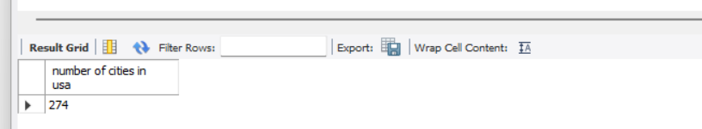
My best friend is from Spain and loves data. so I thought to report back to him the average life expectancy is in Argentina instead:
SELECT Name, Population, LifeExpectancy
FROM country
WHERE Code = 'ARG';
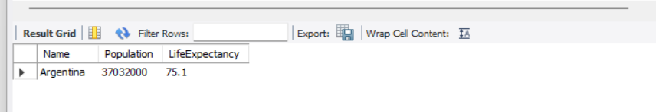

“Actually, I now want to know which country has the highest life expectancy as living in the UK may not be the best choice:”
SELECT Name, LifeExpectancy
FROM country
ORDER BY LifeExpectancy DESC
LIMIT 1;
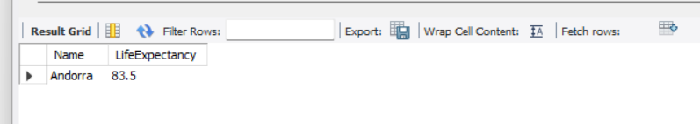
ANDORRA…. Why are we not all booking one-way flights?

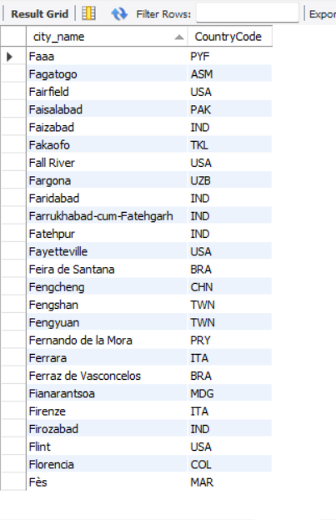
Instead of using bad language, let’s be creative and find cities in the world starting with the letter ‘F’…… in fact, make that 25 cities as the list would be longer than my wife’s shopping list:
SELECT Name AS city_name, CountryCode
FROM city
WHERE Name LIKE 'F%'
ORDER BY Name
LIMIT 25;

This is a SQL statement that displays columns Id, Name, Population from the city table. I decided to limit results to first 10 rows only:
SELECT Id, Name, Population
FROM city
LIMIT 10;
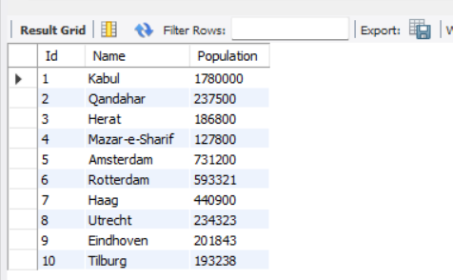

Now I want to find the cities which have a population of over 8,000,000 (million) so I can avoid moving and starting a family there:
SELECT Id, Name, Population
FROM city
WHERE Population > 8000000;
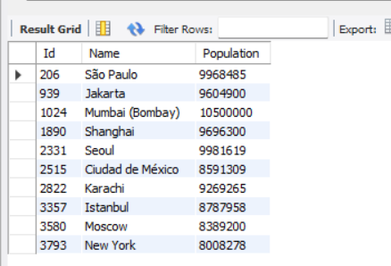

After hours of playing the alphabet game with some friends where we had to alphabetically name cities and points were awarded for cities no one else in our group had heard of. Because of their geographical intelligence, I decided to get some assistance from SQL by writing the following query in the world database dataset:
SELECT Name
FROM city
WHERE Name LIKE 'Be%';
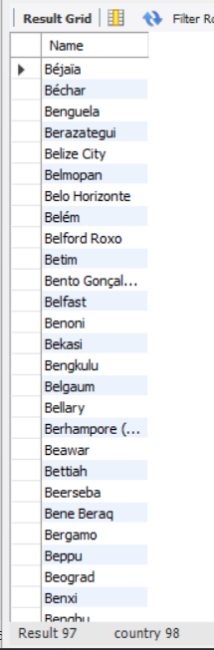

I got maximum points in this round!

As you can see, I struggle with geography, but with the help of writing queries you can explore various datasets and extract specific information. There are many other ways you could utilise queries within a database but I will be ended this project with another useful method that helps me find out the capital city of any country. Some of which I have never heard of:
SELECT Name AS capital_of_spain
FROM city
WHERE ID = (SELECT Capital FROM country WHERE Code = 'ESP');
I couldn’t end this project without biasedly searching for my mother country Nigeria:
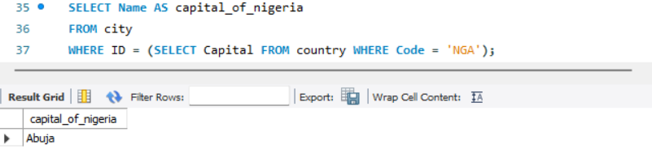
Ooops! Can’t leave out my wife’s country in case she looks at my project:
